**Leader Overview**



**Volume Overview**

**Better Together**

*The Christian life is never lived alone. When we become a Christian, we’re adopted into God’s family. We’re welcomed into a community. We’re meant to live and grow in faith together. But that takes humility and intentionality. We grow together as we pray and study Scripture together. We bear responsibility for one another by our encouragement and our honoring of those in authority. God is growing us together as one body, one family.*

**Session Overview**

**Study Together**

*In this* **Live** *session, kids will discover the importance of how studying the Scriptures with others can lead to growing in their faith. Studying God’s Word with other believers helps us to learn more about Him and to learn from others. We are better together.*

**Bible Lesson**

The Bereans Eagerly Search the Scriptures

[Acts 17:10–15](https://ref.ly/logosref/Bible.Ac17.10-15)

**Faith Fact**

We can learn and grow together.

**Faith Verse**

[Ephesians 4:3](https://ref.ly/logosref/Bible.Eph4.3) (NLT)

Make every effort to keep yourselves united in the Spirit, binding yourselves together with peace.

**Preparing for the Session**

**Leader Preparation Time: 20–25 Minutes**

|  |
| --- |
| ***You Will Need***  ***Large Group***   * *Bible* * *Worship songs (Song suggestions: “Good Grace” by Hillsong United; “Speak Life” Lyric Video by TobyMac; “Tremble” by Bethel Music)* * *For groups not using a phone or tablet only, add:*   *• Projector or TV*  *• Laptop*  *•* ***Faith Fact Slide***  ***• Faith Verse Video or Slide***  ***• Bible Lesson Video***  ***• Teaching Point Slides 1–3***  ***Small Group***   * ***Small Group Group Connection Page****, one per kid* * *Pencils or pens* * *Bibles for kids in the group to share* * *NLT Bibles, two per group* * ***Small Group Activity Page****, one per kid* * *Pencils, one per kid*   *To access session content and videos from a computer, visit:* [BibleEngagementProject.com/downloads](https://bibleengagementproject.com/downloads) |
| ***Getting Ready***  ***Large Group***   * *Download videos and slides if needed.* * *Select worship song(s) and have them ready to play.* * *Read the Bible Lesson Scripture to prepare for Teaching Time.*   ***Small Group***   * *Print copies of the* ***Small Group Group Connection******Page****, one per kid.* * *Print copies of the* ***Small Group Activity Page****, one per kid.*   *First time leading* Live *for Kids? Check out the* [Facilitator Guide](https://0b769b0ed3569ef9d18b-f88d8272f61086866d50d048b43ef630.ssl.cf2.rackcdn.com/sites/biblengagementproject/Listen_Facilitator_Guide.pdf)*.* |

**Large Group**

**30 Minutes**

*See what’s needed at the beginning of the session.*

**Introduction**

Welcome! I’m glad you’re here. There is no better way to learn about being better together than being together while we do it. Wouldn’t you agree? *(Group response)* Last time, we learned about the importance of praying together. Prayer is powerful because God hears and can answer when we pray!

Today, we’ll talk about being better together when we study together. Now, I’m not talking about studying for a test in school. I’m talking about studying God’s Word. That’s one of the things we do together at church, but church isn’t the only place we should study God’s Word. Where else can we study God’s Word together? *(Allow responses.)*

We can study God’s Word anywhere because we have access to it on our phones, devices, and most of us own a printed Bible as well.

• *Optional: Offer to send a Bible home with any kid who doesn’t own a Bible of their own.*

**Faith Fact**

It’s so important that we know what God’s Word says and understand what it means. Our Faith Fact today is **We can learn and grow together.**

• *Show the* ***Faith Fact Slide.***

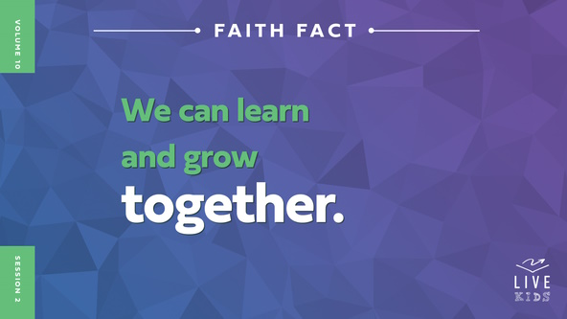

Let’s say the Faith Fact a couple of more times. When we say the word *learn*, let’s pretend to open a Bible and read it. When we say the word *grow*, let’s hold our hands out facedown and move them up in the air. Ready? **We can learn and grow together**. Let’s say that one more time. **We can learn and grow together.**

**Game**

**Growing Chains**

We are better when we learn and grow together instead of trying to do it on our own. We all have our strengths and weaknesses. When we work together, we can be strong for each other. For our game, you’ll work together to grow a people chain. You’ll start with names that start with the letter *A* and keep on moving to the end of the alphabet. As you join the line, link arms in alphabetical order to create a chain.

By the end of the game, we should have a giant chain that includes everyone. Then, we’ll see if we can remain linked together as we make our way around the entire room. Let’s play.

• *After kids make the chain, have the last person lead the chain around the room.*

It was hard to put that chain together in the correct order, but you did it by working together. We are stronger when we take the time to grow and do things together.

**Worship**

I love learning and growing through studying God’s Word, but it’s even better when we get to do it together. Worship is another thing that is better when we do it together. Let’s worship God now by singing.

• *Lead the kids in singing one or two praise songs. See suggestions at the beginning of the session.*

**Bible Lesson**

That was amazing! I love hearing all of us singing and worshipping God together. Let’s pray and ask God to show us how we can learn and grow in our faith when we study His Word together.

**Prayer**

|  |
| --- |
| *Dear God, thank You for giving us Your Word to help us in every situation we face. Help us to learn something new and grow in our faith as we study it together. Amen.* |

**Video Intro**

Just before we look at the Bible story, let’s watch this video.

• *Play* ***Bible Lesson Video****.*

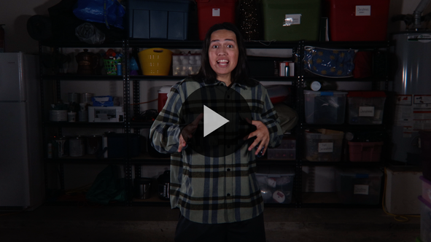

**Bible Story**

**The Bereans Eagerly Search the Scriptures**

That video was a great lead-in to our Bible story today. After Jesus went back to heaven, His followers were busy telling people about Him and growing the community of believers. Many of His followers went from town to town telling people His message. Do you think everyone who heard about Jesus accepted Him? *(Group response.)* Sadly, they didn’t. Some people did choose to accept Jesus and became believers. But some tried to have the believers thrown into prison or drove them out of their town.

In our Bible story, Paul and his friend Silas had just come from a town called Thessalonica where some people accepted their message. Many others in Thessalonica wanted them to get out of their town. People tried to find them, but the believers had sent Paul and Silas on to the next town in their ministry journey. That town was Berea. Let’s read about how some people of Berea accepted Paul and Silas’s message.

**Teaching Time**

Can you imagine traveling from town to town like Paul and Silas did? *(Group response)* They moved around, never knowing exactly how long they would be able to stay in each place. They would share the message about Jesus until it became too dangerous, or God told them that it was time to go. Then, they would move on to the next town. Do you think they were exhausted? *(Group response.)*

I’m sure they were ready to give up many times, but their commitment to God kept them going. They knew their message was worth all the traveling and even putting their lives at risk. They knew the value of helping people learn about Jesus and God’s Word.

Our Faith Fact reminds us that we can learn about God’s Word and grow in our faith together. Because followers of Jesus like Paul and Silas were willing to keep sharing their faith, we now can know God. **We can learn and grow together.**

Let’s read how the people in Berea responded to Paul and Silas’s message. Grab your Bible or pull up a Bible app on your device. Turn to [Acts 17:10–15](https://ref.ly/logosref/Bible.Ac17.10-15).

• *In order to keep Large Group time moving along, we recommend that the leader reads the Scripture portions aloud.*

• *Optional: Remind the kids to mark this place with their Bible bookmark so they can read it on their own at home.*

**1. Paul and Silas taught the people in Berea.**

• *Show the* ***Teaching Point 1 Slide.***

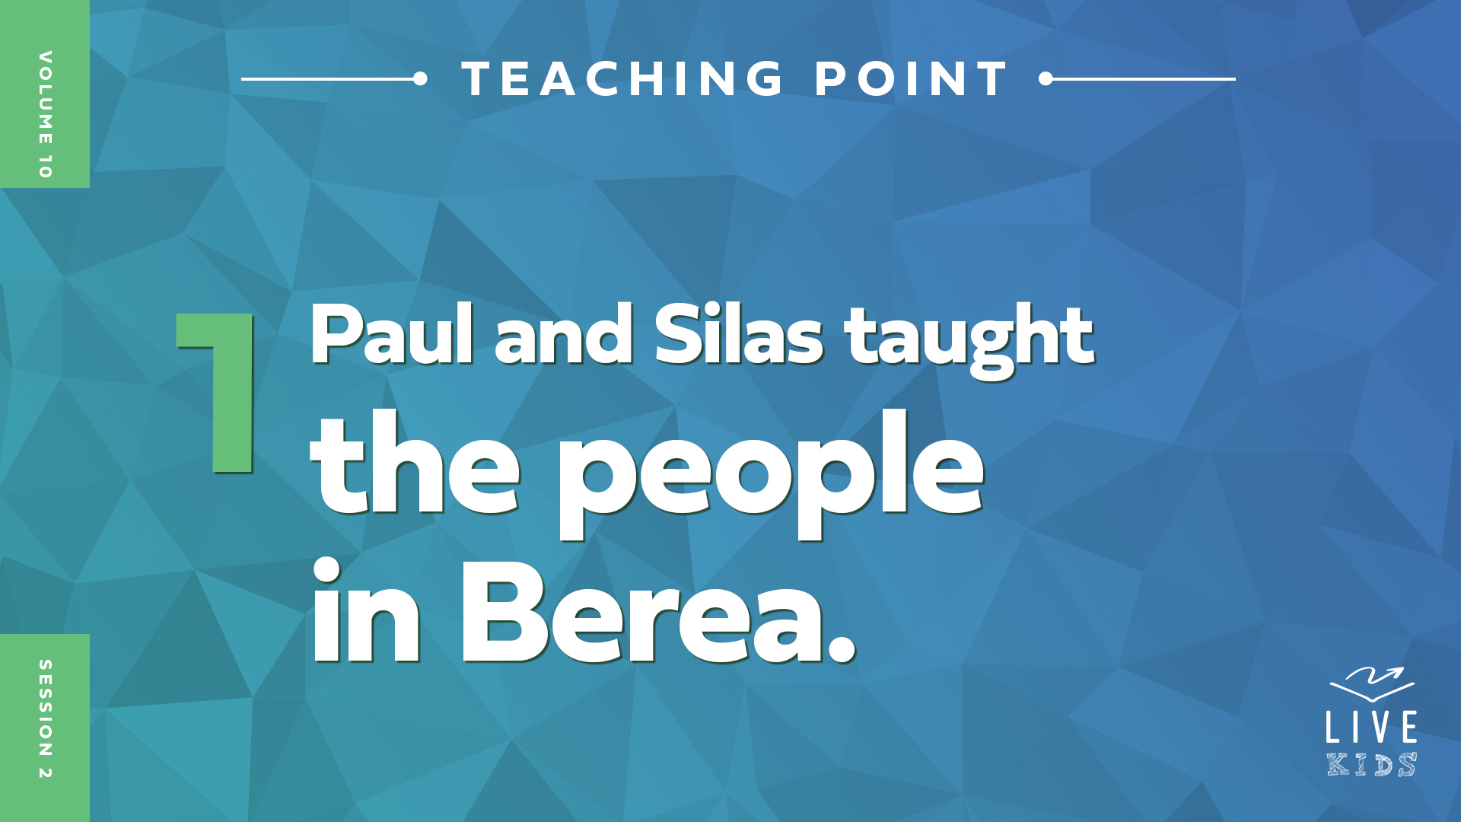

• *Read* [*Acts 17:10–11*](https://ref.ly/logosref/Bible.Ac17.10-11)*.*

Paul and Silas probably came to Berea feeling discouraged after the way they were treated in Thessalonica. They had no clue how the people in Berea would respond to their message. Would they be open to what Paul and Silas had to say? I’m sure Paul and Silas were thrilled because the people of Berea were so eager to listen to their message, unlike the people of Thessalonica.

I can relate to Paul and Silas. I’m here with a message to share with you. I want to learn from God’s Word together with you. But I’m not sure who will be open and eager to listen and who will be distracted. Our Faith Fact reminds us of what’s important to God. **We can learn and grow together.**

I know it’s easy to be distracted or even bored because you may have heard the Bible story before. Here’s a great way to avoid feeling that way. Remember, the message isn’t my message. It’s God’s message from His Word. The Bible isn’t just a book that was written a long time ago by a bunch of men. It’s the living and active Word of God, and God is still speaking to us today through His Word.

**2. The Bereans studied the Scriptures together to find the truth.**

• *Show the* ***Teaching Point 2 Slide.***

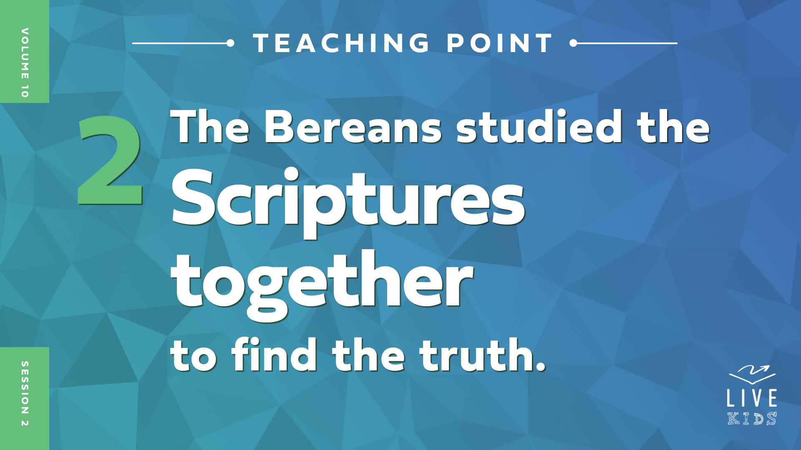

• *Read* [*Acts 17:12*](https://ref.ly/logosref/Bible.Ac17.12)*.*

How did the people of Berea respond to what Paul and Silas taught? *(Allow responses.)* Not only were they open and eager to listen to Paul’s message, but then they searched the Scriptures for themselves. And best of all, they believed in Jesus as a result!

Remember the Bereans didn’t know Paul and Silas before this. They could have just taken Paul and Silas’s word for it and agreed with what they said. Would that have been a wise thing to do? *(Group response)* Probably not since they didn’t know them. It’s important that we take the time to study the Bible for ourself to make sure we know God’s truth. *(Hold up the Bible while you talk.)*

Raise your hand if you own a Bible or have access to a Bible app on your phone or device. *(Group response)* That’s pretty much everyone in this room.

How can we know God’s truth if we don’t spend time searching in His Word? Some people may say that you can make up your own truth rather than trust God’s truth, but that’s wrong. Can you trust something as true if anyone can change it, twist it, and make it their own? *(Group response)* No, you can’t! When some of the Bereans searched the Scriptures, they realized that Paul and Silas’s message was correct. It was God’s truth. Many of them chose to believe in Jesus and put their faith in Him.

**3. Others didn’t believe and caused Paul to leave Berea.**

* *Show the* ***Teaching Point 3 Slide.***

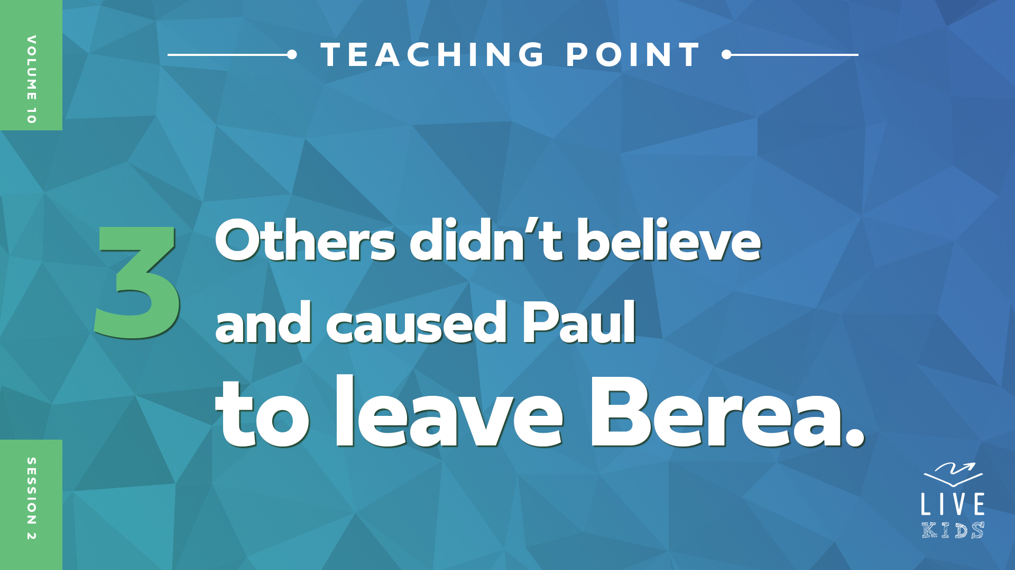

• *Read* [*Acts 17:13–15*](https://ref.ly/logosref/Bible.Ac17.13-15)*.*

Can anyone remember where Paul and Silas came from before they entered the town of Berea? *(Allow responses.)* That’s right, it was a city named Thessalonica. Some people there must not have liked Paul and Silas at all. When they heard that Paul was preaching the Word of God in Berea, they went there to try and stir up even more trouble for Paul and Silas.

When the believers there heard that the people from Thessalonica were causing trouble, they sent Paul all the way to Athens and sent some people with him to protect him. Silas and Timothy, who were Paul’s ministry partners, stayed behind in Berea for a little while.

We don’t know exactly how long Paul and the others were in Berea telling them about Jesus and God’s Word, but they made a big impact on the people there. People in Berea opened their hearts and minds to Paul’s message. That challenged them to study the Word together to find the truth for themselves. They are great examples of our Faith Fact. Say it with me. **We can learn and grow together.**

**Prayer and Response**

*Consider playing a worship song softly in the background while kids pray.*

The Bereans’ lives were changed forever because they heard Paul’s message about Jesus. They probably kept on following Jesus and studying God’s Word after Paul left. They continued to learn and grow in their faith through studying the Scriptures together. God’s Word isn’t like any other book that has ever been written. God inspired all of it. That means as we learn new things from the Bible, we can grow to be more like Jesus. Let’s pray together and ask God to help us learn and grow as we study His Word every day.

• *Leaders should pray with the kids.*

**Prayer**

*Optional: Have the kids repeat phrases of the prayer after you.*

|  |
| --- |
| *Dear God, thank You for opening my mind and heart to Your Word. Help me to learn the truth and grow in my faith as I study the Scriptures together with others. Amen.* |

**Faith Verse**

Our Faith Verse tells us that we should make every effort to be united with others. Let’s say our Faith Verse and do the actions together.

• *Play* ***Faith Verse Video****.*

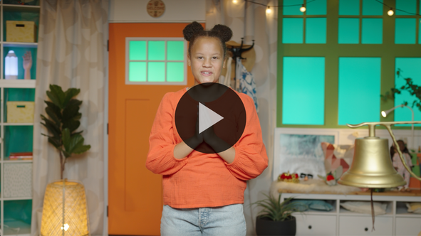

[Ephesians 4:3](https://ref.ly/logosref/Bible.Eph4.3) (NLT)

Make every effort to keep yourselves united in the Spirit, binding yourselves together with peace.

**Faith Fact**

Before we go to our small groups, let’s review our Faith Fact again. **We can learn and grow together.**

• *Show the* ***Faith Fact Slide****.*



Let’s say our Faith Fact together three times, growing louder each time we say it. **We can learn and grow together**. *(Repeat two more times, getting louder each time.)* Remember to spend time studying God’s Word this week on your own before we come back and study it together next time.

• *Dismiss kids to Small Group time or to go home if your group time ends here.*

**Small Group**

**30 Minutes**

*This section can be done in conjunction with the large group or on its own if you do small groups with your kids. During Small Group time, the goal is to connect the kids with the Word of God and to each other. All activities are led by the small group leader.*

**Group Connection**

**Study Scripture Together**

|  |
| --- |
| ***You Will Need***   * ***Small Group Group Connection Page****, one per kid* * *Pencils or pens, one per kid*   *No prep needed for this activity.* |

The people of Berea listened to Paul’s message, but they didn’t just take his word for what he said the Scriptures meant. They searched and studied the Scriptures for themselves, and they did it together. They wanted to confirm that Paul and Silas were teaching the truth that is found in God’s Word.

• *Hand out a copy of the* ***Small Group******Group Connection Page*** *and a pencil to each kid.*

We can study Scripture together too. As we read and talk about God’s Word, we will learn from each other. Let’s try it right now.

• *Lead kids through the steps on the page as a group. Encourage everyone to share their responses, so they can learn from each other.*

Thanks for studying Scripture together with me!

**Bible Lesson Recap**

• *If small group activities are not immediately following large group time, you may want to read the Bible story passage before the discussion.*

|  |
| --- |
| ***You Will Need***   * *Bibles for kids in the group to share*   *No prep needed for this activity.* |

**Bible Story Review: The Bereans Eagerly Search the Scriptures** [**Acts 17:10–15**](https://ref.ly/logosref/Bible.Ac17.10-15)

Paul and Silas were no strangers to travel. They were constantly traveling from town to town. Why did they constantly travel? Because they wanted to share their faith in Jesus with as many people as possible. Back then, entire towns of people had not heard about Jesus or about any of the things He had done.

There were only two ways to spread the good news: write long letters that took a long time to get people or travel to the towns to tell people in person. Do you think reading a letter or listening to a live person would make it more likely for someone to believe in Jesus? *(Group response)* For most people, I think it would be listening to a live person.

That’s why Paul and Silas were on this missionary journey. They had just come from a town called Thessalonica where a lot of people got mad at them because they were talking about Jesus. Then they went to a town called Berea and were happy to find that people there were eager to learn from them.

The people of Berea listened to Paul’s message and searched the Scriptures to make sure that his message lined up with the truth of God’s Word. When the Bereans realized that Paul’s message was founded on the truth in God’s Word, they accepted it and put their faith in Jesus. Unfortunately, people from Thessalonica showed up in Berea and tried to cause trouble. Paul and his friends had to move on to their next ministry stop to avoid danger.

• *Give each kid a Bible and read the Bible story together.*

**Group Discussion**

*Feel free to use all or just a few questions as a jumping-off place for good discussion. Questions marked with * are designed for more conversation. Adjust the questions based on the age or maturity of your group. Typically, older kids will be able to dive a little deeper than younger ones.*

**Questions**

Who went to Berea to share their message?

How did the Bereans figure out if Paul and Silas were teaching the truth?

* What do you think it was like for Paul and Silas to travel from town to town sharing the good news?

Why do you think the Bereans searched the Scriptures?

What happened because the Bereans searched the Scriptures?

How can we find God’s truth?

* What are some ways we can grow together by studying God’s Word?

* How can we share the truth in Scripture with others?

**Live It**

**Faith Fact**

Our Faith Fact today is **We can learn and grow together**. The Bereans were great examples of that. They searched the Scriptures every day to make sure every message they were hearing lined up with the Word of God. It is so important that we make sure that the truths we are living by are found in God’s Word and not made up by someone else.

**Challenge**

One of the best ways to make sure you are living by the truth in God’s Word is to spend time studying it. Maybe you aren’t very good at studying the Bible by yourself. You probably know someone who is more experienced. Ask a parent, older sibling, or friend to study God’s Word with you this week. When you read about something you don’t understand, don’t feel embarrassed to ask for help to you understand it. Remember, it’s not enough just to read or know God’s Word. We need to understand it and apply it to our life for it to really make a difference.

**Prayer**

*Finish group discussion by sharing prayer requests and praise reports. Keep track of your small group’s prayer requests and review them each time you meet.*

• *Have kids share and pray for each other’s prayer requests.*

|  |
| --- |
| *Dear God, help us to study Your Word this week and to understand it, and not just to check Bible reading off our to-do lists. We want to know and understand Your Word so that it can change how we live. Amen.* |

**Faith Verse Review**

|  |
| --- |
| ***You Will Need***   * *NLT Bibles, two per group*   *No prep needed for this activity.* |

Last time we started learning a new Faith Verse. Our Faith Verse is [Ephesians 4:3](https://ref.ly/logosref/Bible.Eph4.3). It teaches us the importance of being together with other people who believe like we do.

• *Show* ***Faith Verse Video****.*



[Ephesians 4:3](https://ref.ly/logosref/Bible.Eph4.3) (NLT)

Make every effort to keep yourselves united in the Spirit, binding yourselves together with peace.

Let’s say it together a couple of times before we do a fun Faith Verse activity together.

• *Say the verse as a group a couple of times.*

**Faith Verse Fun**

**Scripture Pass**

For our game today, we’ll divide the group into two teams, and you’ll line up in your teams. I’ll give a Bible to the first person in each team. When I say, “Go!” you’ll pass the Bibles down the line. Instead of just handing it to the next person, you’ll alternate how you pass the Bible. The first person will pass it over their head. The next person will pass it between their legs. You’ll alternate the passing of the Bible until it reaches the end of the line.

When your team’s Bible gets to the end of the line, the last person will look up the Faith Verse in [Ephesians 4:3](https://ref.ly/logosref/Bible.Eph4.3) and read it aloud. The first team to find and read the Faith Verse wins.

• *Divide the group into teams and play the game.*

Wow! That was a lot of fun! Don’t forget to pass the Scripture this week and share it with others.

**Activity Page**

**Word Search**

|  |
| --- |
| ***You Will Need***   * ***Small Group Activity Page,*** *one per kid* * *Pencils, one per kid*   ***Getting Ready***   * *Print copies of the* ***Small Group Activity Page****, one per kid.* |

Are you good at word searches? *(Group response)* This word search is special because you will be searching for each word in our Faith Verse. See how fast you can find and circle each of the words.

• *Hand out a copy of the* ***Small Group Activity Page*** *and a pencil to each kid.*

**Dismissal**

We are better together when we pray, study God’s Word, and grow in our faith. All those things are a lot more fun and effective when we do them together with other believers. That’s why I’m so thankful for all of you. We are better together. Let’s pray together one more time.

**Prayer**

|  |
| --- |
| *Dear God, thank You for Your Word to study and for friends to study Your Word with. Help us to learn more about Your Word this week and to grow even stronger in our faith together. Amen.* |

**Faith Fact Recap**

• *Show the* ***Faith Fact Slide****.*



Remember today’s Faith Fact as you go home and choose someone to share it with. Let’s say it together. **We can learn and grow together.** How can you learn more about God’s Word and grow in your faith this week? *(Allow responses.)* Those were some great answers. I can’t wait to see you next time!

• *Send home the* ***Small Group******Activity Page*** *and* ***Small Group Group Connection Page.***

• *Remind parents that there are* ***Family Devotions*** *available on the app to do with their kid.*

• *Tell everyone the date and time for the next session.*